System GUI Design

Author has used templating modal. It is like MVC (Modal View Controller) design pattern where business logic is separated from html code. In the design pattern, view is separated from programming logic. All design and functionality part is hard-coded by author.

GUI design is one of the most important part of software development. If the software is not user-friendly it won’t be successful. Below are the some of the screenshot of the gui design of the system.

Home page:

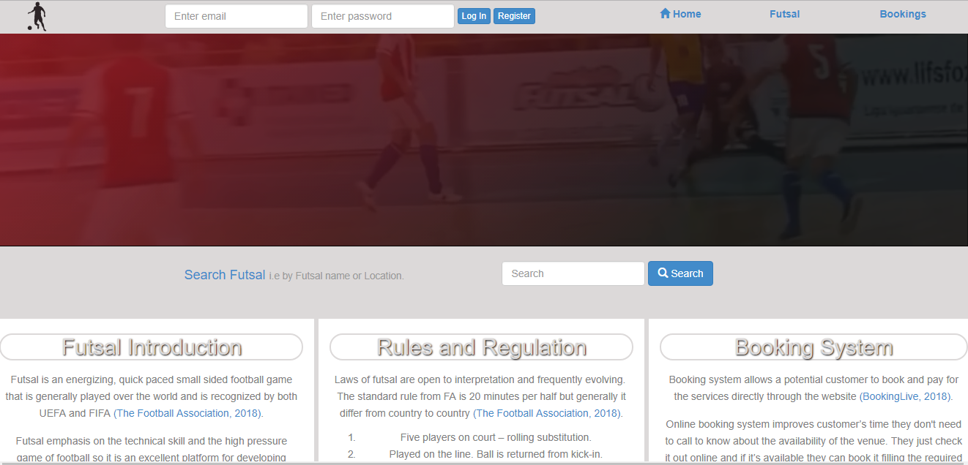

Figure 1: home page of the system.

Booking page:

Booking page is where end-user book futsal venue with his/her desired time and date. If the date and time is already booked one then it will show unavailable with red color on it.

Gui for booking page is below.

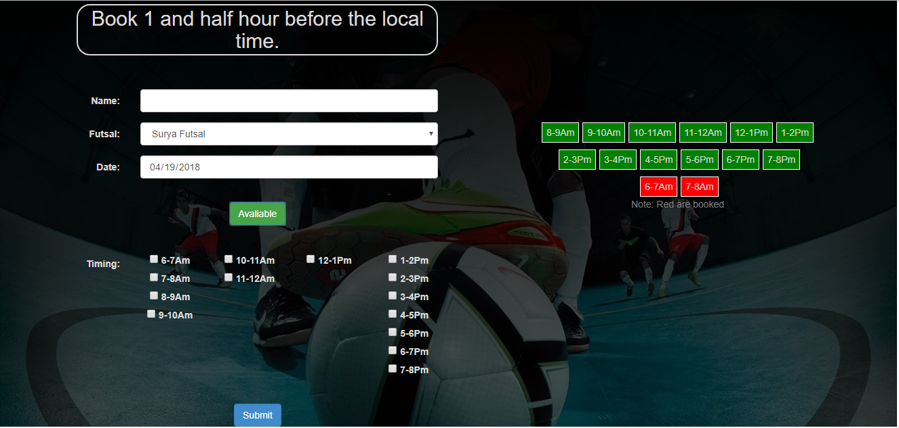

Figure 2: booking page of the system.

Futsal Vendor Log-in page:

Each futsal vendor log-in with their email id and password and view, edit and delete information regarding their futsal. The futsal vendor log-in page look like below.

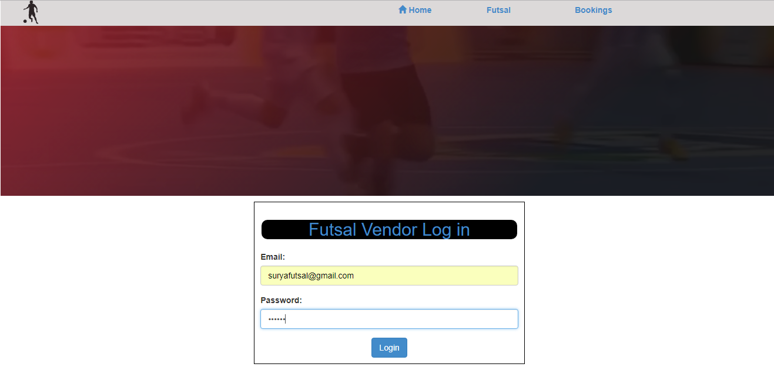

Figure 3: futsal vendor log-in page.

Futsal Vendor content page:

After validating their credentials they are directed to respective page showing only their information.

Futsal vendor content page look like.

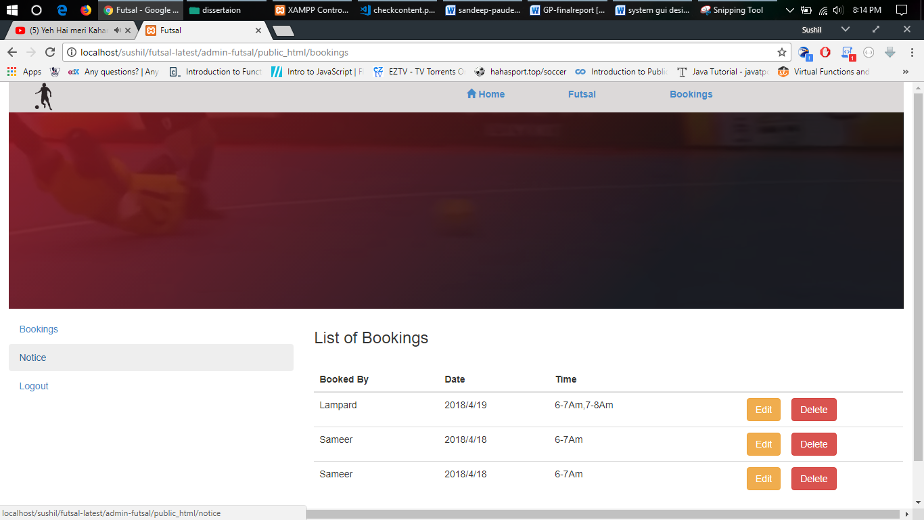

Figure 4: vendor content page.

Admin log-in page:

The main admin is system developer in this case the author himself. Login page validate whether the person is admin or not. Admin login page is shown below.

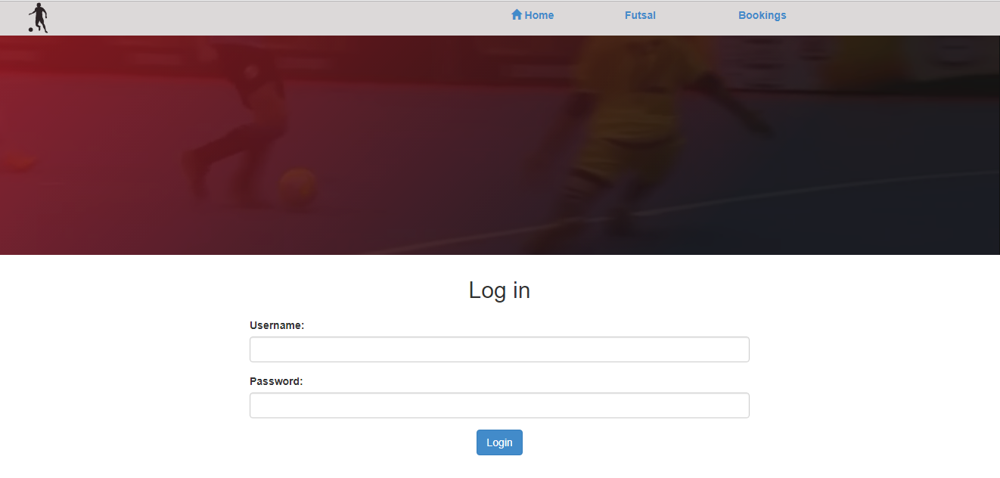

Figure 5: admin login page.

Admin content view page:

Admin can view all the information about the system. Admin can view, add, modify and delete many things. The admin page looks like.

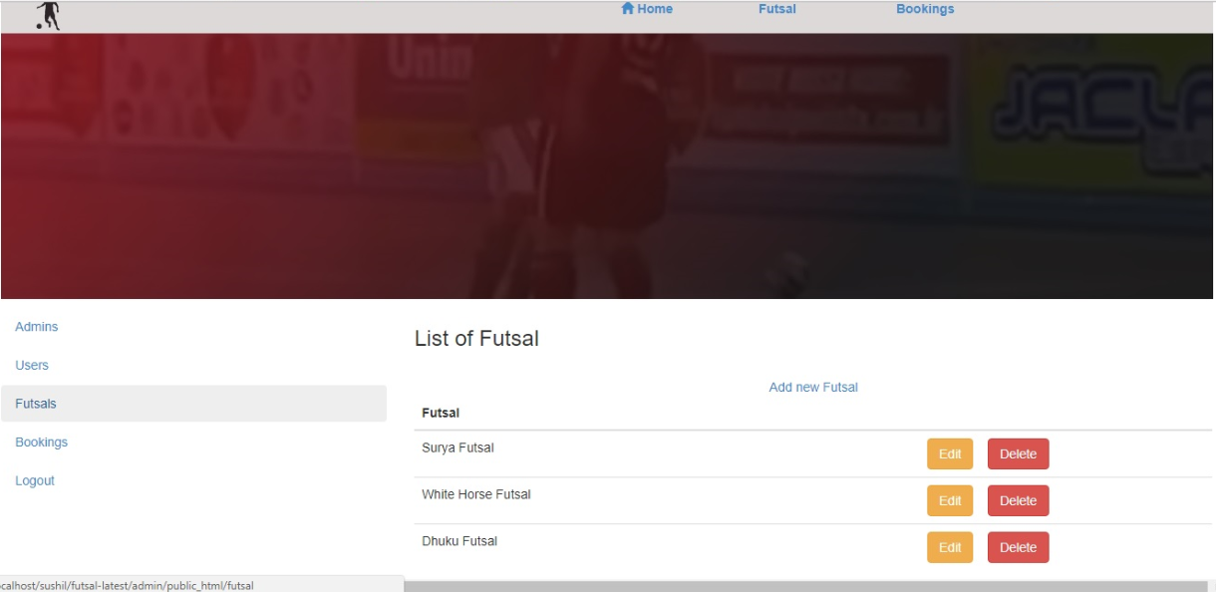

Figure 6: admin content view page.

Admin content add page:

Gui for admin to add new row on specific table.

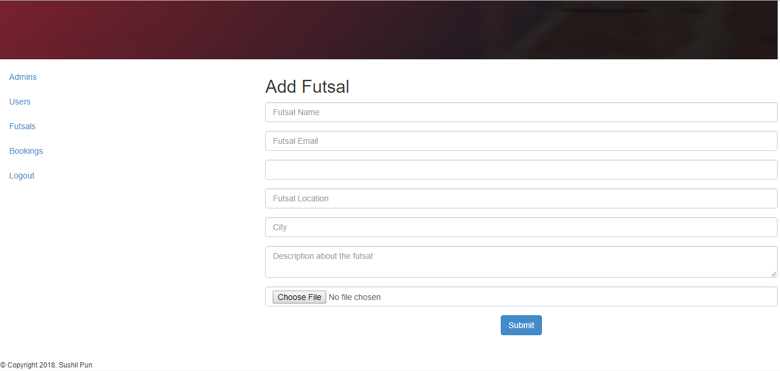

Figure 7: admin content add page.

Admin content edit page:

Gui that enable admin to edit information on the system. Here is the gui for edit certain page.

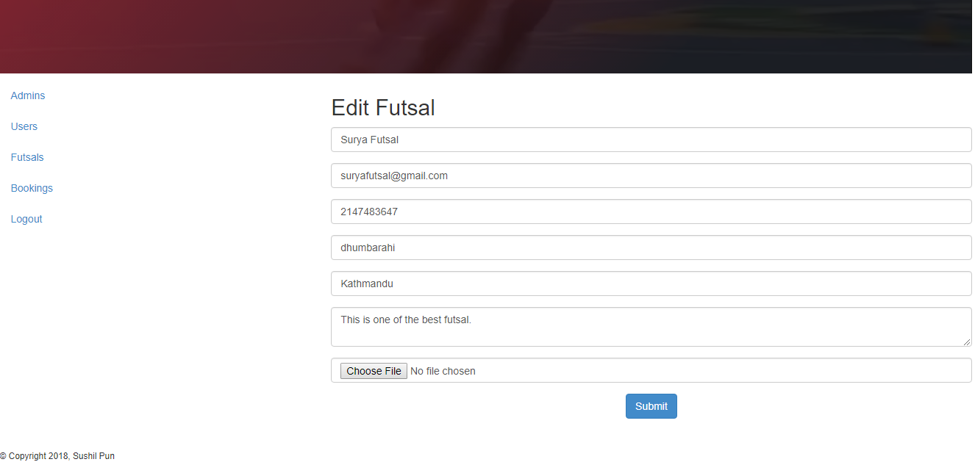 Figure : admin content edit page.

In order to be a user-friendly system it must be developed with mobile first design concept. It must be applicable to all sizes devices.

|  |  |  |
| --- | --- | --- |
|  |  |  |

Figure 9: system design with mobile first concept.